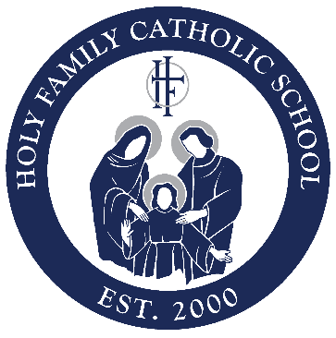

**LEGACY SOCIETY**

As evidence of my desire to provide a legacy of support to Holy Family Catholic High School, I am pleased to inform you that I intend to leave a gift to Holy Family in my estate plans. I understand that this commitment is revocable and can be modified by me at any time.

**It is my intent to leave a legacy for the benefit of Holy Family Catholic School (Please check all that apply).**

* I have planned a bequest of $ from my estate to Holy Family Catholic School in my will*.
* I have named Holy Family Catholic School as the beneficiary of ___% of my estate.
* I have named Holy Family Catholic School as the beneficiary of the reside of my estate*.
* The trustee of my Living or Charitable Remainder Trust* is instructed to distribute $________of the remaining corpus of the trust to Holy Family Catholic School

**Please enroll me in Holy Family Catholic School's LEGACY SOCIETY under the following conditions:**

* You have permission to publish my name in relation to LEGACY SOCIETY (print and internet) as a motivation for others to leave future gifts to benefit Savio.
* Please do not publish my name as a member of LEGACY SOCIETY (except on my personalized certificate).

**Please proceed to the other side to complete this form.**

Please **PRINT your name** exactly how you would like it to read in our donor listing on the line above.

Name (if different than above) Birthdate (MM/DD/YEAR)

Address: City State Zip

Home Phone Cell Phone Email address

Date Donor Signature